**A PROJECT REPORT**

**ON**

**Meetup Platform**

**SUBMITTED TO THE SAVITRIBAI PHULE PUNE UNIVERSITY, PUNE**

**IN THE PARTIAL FULFILLMENT FOR THE AWARD OF THE DEGREE**

**OF**

**BACHELOR OF BUSINESS ADMINISTRATION**

**IN**

**COMPUTER APPLICATION**

**BY**

Vijay Sunil Gholve 5929

**UNDER THE GUIDANCE OF**

Prof. Watpade A.S.

****

**Year 2025-26**

**  **

***Rayat Shikshan Sanstha's***

**S. M. JOSHI COLLEGE, PUNE**

**HADAPSAR, PUNE 411028**

**DEPARTMENT OF COMPUTER SCIENCE AND APPLICATION**

**2025-26**

**CERTIFICATE**

This is to certify that the project report entitled

**Meetup Platform**

**Submitted by**

Vijay Sunil Gholve Examination Seat No.:5929

is a bonafide work carried out by them under the supervision of **Prof. Watpade A.S.** and it is approved for the partial fulfillment of the requirement of Savitribai Phule Pune University for the award of the Degree of **Bachelor of Business Administration in (Computer Application).**

This project report has not been earlier submitted to any other Institute or University for the award of any degree or diploma.

**Prof. Watpade A. S. Hon. Sangeeta Yadav**

Project Guide HOD

**Internal Examiner** **External Examiner**

**ACKNOWLEDGEMENT**

We feel great pleasure in expressing our deepest sense of gratitude and sincere thanks to our guide **Prof. Watpade A.S.** for their valuable guidance during the Project work, without which it would have been a difficult task. I have no words to express my sincere thanks for valuable guidance, extreme assistance and cooperation extended to all the Staff Members of our department.

This acknowledgement would be incomplete without expressing our special thanks to **Hon. Sangeeta Yadav,** Head of the Computer Application department for her support during the work.

We would also like to extend our heartfelt gratitude to our Principal, **Dr. S. T. Salunkhe** who provided a lot of valuable support, mostly being behind the veils of college bureaucracy.

Last but not the least we would like to thank all the Teaching, Non-teaching staff members of our Department, our Parents and our colleagues those who helped us directly or indirectly for completion of this project successfully.

Vijay Sunil Gholve Examination Seat No.:5929

|  |  |  |  |  |  |
| --- | --- | --- | --- | --- | --- |
|  | | | **INDEX** |  |  |
| **Sr.No** |  | | **Chapter Name** | **PageNo.** |  |
| **1** |  | | **Abstract** | **1** |  |
| **2** |  | | **Introduction** | **6** |  |
|  | 2.1 | | Motivation |  |  |
|  | 2.2 | | Problem Statement |  |  |
|  | 2.3 | | Purpose/Objective and Goals |  |  |
|  | 2.4 | | Literature Survey |  |  |
| **3** | 2.5 | | Project Scope & Limitation  **System Analysis** | **8** |  |
|  | 3.1 | | Existing System |  |  |
|  | 3.2 | | Scope and Limitations |  |  |
|  | 3.3 | | Perspective and Features |  |  |
|  | 3.4 | | Stakeholders |  |  |
| **4** | 3.5 | | Requirement Analysis  **System Design** | **16** |  |
|  | 4.1 | | Design Constraints |  |  |
|  | 4.2 | | System Model: DFD |  |  |
|  | 4.3 | | Data Model |  |  |
|  | |
| **5** |  | | **Implementation Details** | **22** |  |
|  | 5.1 | | Software Requirements |  |  |
|  | 5.2 | | Hardware Requirements |  |  |

|  |  |  |  |
| --- | --- | --- | --- |
| **6** |  | **Outputs and Report Testing** | **24** |
|  | 6.1 | Test Cases |  |
|  | 6.1.1 | Black Box Testing |  |
|  | 6.1.2 | White Box Testing |  |
| **7** |  | **Conclusion & Recommendations** | **32** |
|  | 7.1 | Conclusion |  |
|  | 7.2 | Recommendations |  |
| **8** |  | **Future Scope** | **34** |
| **9** |  | **Bibliography & References** | **36** |

**CHAPTER 1:**

**ABSTRACT**

## **Abstract**

This project report analyzes VRITILIFE Skin Care and Health Care Products, focusing on the company's current market strategy, product positioning, and potential for digital transformation. The study investigates how business administration principles can be applied, utilizing computer application tools, to optimize VRITILIFE's operations, enhance customer relationship management, and drive market penetration in the competitive wellness industry. The research identifies key areas for improvement in online presence and service delivery, concluding with strategic recommendations designed to ensure VRITILIFE's scalable and sustainable growth.

**CHAPTER 2:**

**INTRODUCTION**

**Introduction**

#### **Motivation**

In an increasingly digital and interconnected world, the significance of genuine local connections and shared experiences remains paramount for both community well-being and personal development. However, individuals often face substantial challenges in discovering local groups aligned with their specific interests, organizing events efficiently, and managing attendee participation. The current landscape of social platforms often results in a fragmented experience, with users relying on disparate tools or being geographically limited in their search for like-minded communities. The motivation for developing ConnectLocal stems from this recognized need for a unified, integrated, and user-friendly platform that empowers individuals to forge meaningful local connections and collectively pursue their shared passions.

#### **Problem Statement**

The existing landscape for local community engagement and event organization is characterized by several significant challenges that hinder effective interaction. First, a **discovery fragmentation** problem exists where users struggle to find groups that align with their niche interests, as relevant information is scattered across various social media platforms and unorganized websites. Second, **organizational inefficiency** plagues group leaders who must manually manage member lists, schedule events, and disseminate updates using disparate and unintegrated tools. Finally, there is a pervasive issue of **limited engagement tools**, as many platforms lack robust features for fostering ongoing communication, discussion, and feedback within groups, which ultimately undermines community cohesion. ConnectLocal seeks to directly address these issues by providing a dedicated and centralized solution.

#### **Purpose/Objective and Goals**

The overarching **purpose** of the ConnectLocal project is to develop a comprehensive and intuitive web platform that simplifies the entire lifecycle of creating, joining, and managing local community groups and events. This will foster stronger social bonds and facilitate shared experiences. Our **primary objectives** are:

Our **goals** are to achieve these objectives through the implementation of core functionalities such as user management, group and event creation tools, integrated messaging, and a robust search engine, all while prioritizing a scalable and secure architecture.

#### **Literature Survey**

A comprehensive review of existing literature was conducted to understand the current landscape of event management systems, including a meticulous examination of platforms such as Meetup.com, Eventbrite, and Facebook Events. This survey provided a clear understanding of the strengths and limitations of these solutions. Key areas of investigation included emerging technologies like AI for personalization, real-time communication protocols, and secure digital payment solutions. The survey also informed the selection of the most suitable technological frameworks and established best practices for user experience, security, and scalability. This foundational research ensures that the project is strategically positioned to address existing market gaps with a forward-thinking and robust solution.

#### **Project Scope and Limitations**

The **scope** of Connect Local is defined as a full-stack web application covering user management, group and event management, communication, discovery, and basic analytics. The system will be designed to be fully responsive for use across all devices. The project's **limitations** include not implementing advanced monetization features beyond a primary payment gateway, a lack of built-in live streaming capabilities, and a focus on a single language for initial development. These advanced features will be considered for future iterations of the platform.

**CHAPTER 3:**

**SYSTEM ANALSIS**

**System Analysis**

* Meetup.com: A long-standing platform specifically designed for local groups and events based on shared interests.
* Facebook Groups/Events: A widely used social media feature that allows users to create private or public groups and
* organize events.
* Eventbrite: Primarily a ticketing and event management platform, often used for larger, public events.
* Local Community Forums/Websites: Various smaller, often niche-specific, online forums or websites catering to
* particular local interests.

**Project, Perspective, Features**

* Unified Ecosystem A single platform for group discovery, event organization,

communication, and analytics.

* User-Centric Design Prioritizing intuitive navigation and a clean, modern interface for all user roles.
* Robust Group Management Empowering organizers with fine-grained control over their groups and events.
* Enhanced Discovery Intelligent search and filtering to connect users with highly relevant communities.
* Real-time Engagement Integrated chat, discussion forums, and notifications for dynamic interaction.

**Stakeholders**

* Primary Users:
  + Group Organizers: Individuals or entities responsible for creating and managing groups and events.
  + Group Members/Event Attendees: Individuals who join groups and participate in events.
  + Platform Administrators: The team responsible for maintaining the platform, user support, and overall

system health.

* Secondary Stakeholders:
  + Local Businesses/Venues: Who might host events or

offer services to groups.

* + Community Organizations: Non-profits or associations

looking to expand their reach and engagement.

**Performance Remuements**

* **Response Time:** User interface actions (e.g., loading group pages, submitting RSVPs) should resp Read-Onlyond within 2-3 seconds

under normal load.

* **Scalability:** The system must support concurrent users (e.g., 10,000 active users) and manage a growing number of
* groups and events (e.g., 50,000 groups, 100,000 events) without significant performance degradation.
* **Availability:** The platform should maintain 99.9% uptime, excluding scheduled maintenance.
* **Load Handling:** The system should gracefully handle peak loads during popular event announcements or registration periods.

**Security Requirements**

* Authentication: Secure user authentication using industry-standard protocols (e.g., JWT, OAuth2).
* Authorization: Robust role-based access control (RBAC) to ensure users only access authorized functionalities and data.
* Data Encryption: All sensitive data (e.g., passwords, personal information) must be encrypted both in transit (SSL/TLS)

and at rest (database encryption).

* Input Validation: Comprehensive input validation to prevent common web vulnerabilities (e.g., SQL injection, XSS).
* Privacy Compliance: Adherence to relevant data privacy regulations (e.g., GDPR, CCPA) for user data handling and consent.
* Audit Trails: Logging of critical system actions for security monitoring and incident response.

## **Functional Requirements (FRs)**

* **Registration/Login:** Allow users to register and log in securely via email/password, utilizing **JWT authentication**.
* **Role-Based Access:** Enforce distinct permissions for **Attendee, Organizer, and Administrator** roles.
* **Event Creation (Organizer):** Allow Organizers to create and publish events with details including time, date, venue, category, and banner image.
* **Event Editing/Cancellation:** Allow Organizers to modify event details or cancel events, triggering **notifications** to registered attendees.
* **Advanced Search & Filter:** Allow all users to search for events/groups using **keywords** and filter results by **Category, City, Date Range, and Organizer**.
* **Event Registration:** Enable Attendees to sign up for events, selecting **ticket types** and specifying quantity.
* **QR Code Generation:** Automatically generate a **unique, secure QR code (UUID)** for every purchased ticket.
* **Comment System:** Allow users to post comments and **replies** directly on event pages.
* **Content Moderation:** Allow Administrators to **block inappropriate events** or user accounts.

**CHAPTER 4:**

**SYSTEM DESIGN**

## **Data Model Schema:**

## 

**Event**

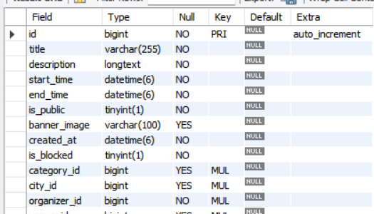

**EventRegistration**

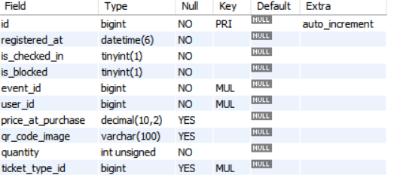

**City**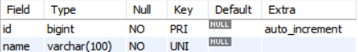

**Category**

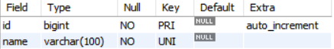

**Like**

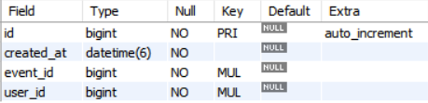

**Users**

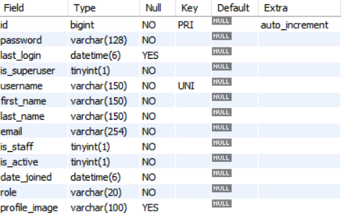

**ER Diagram**

**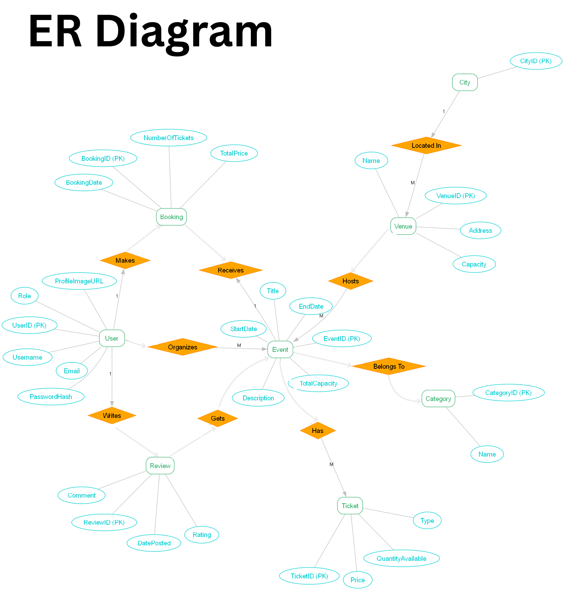**

**DFD LEVEL 0**

**DFD LEVEL 1  
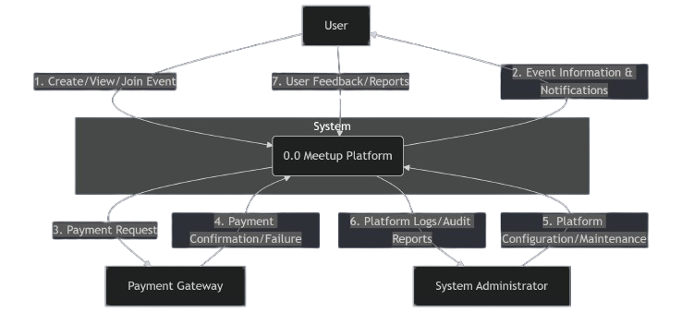**

**Class Diagram**

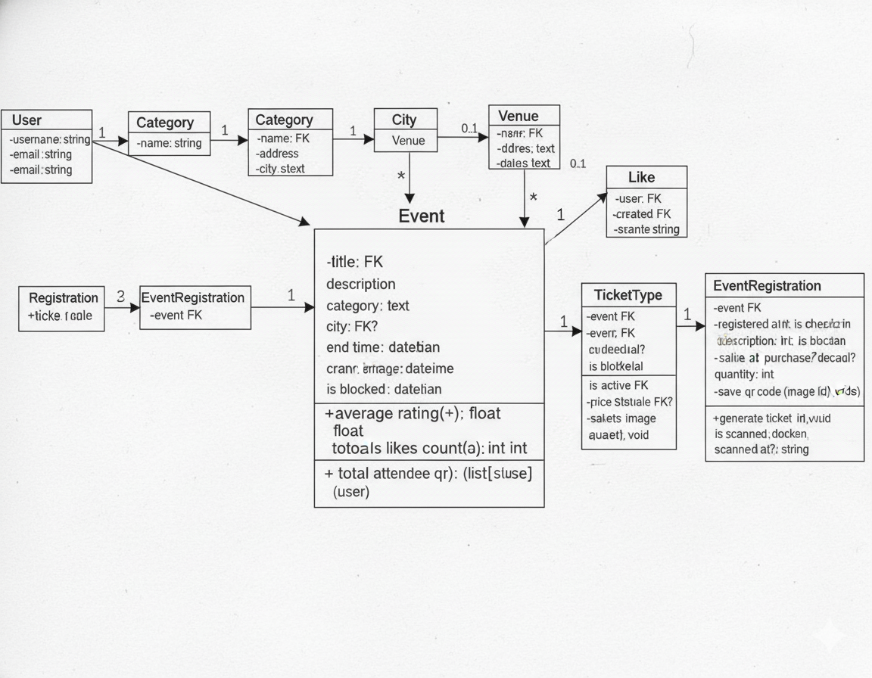

**UseCase Diagram**

**Activity Diagram**

**Activity Diagram**

**Activity Diagram:**

**Séquencé Diagram**

**Class diagram**

**Collaboration diagram**

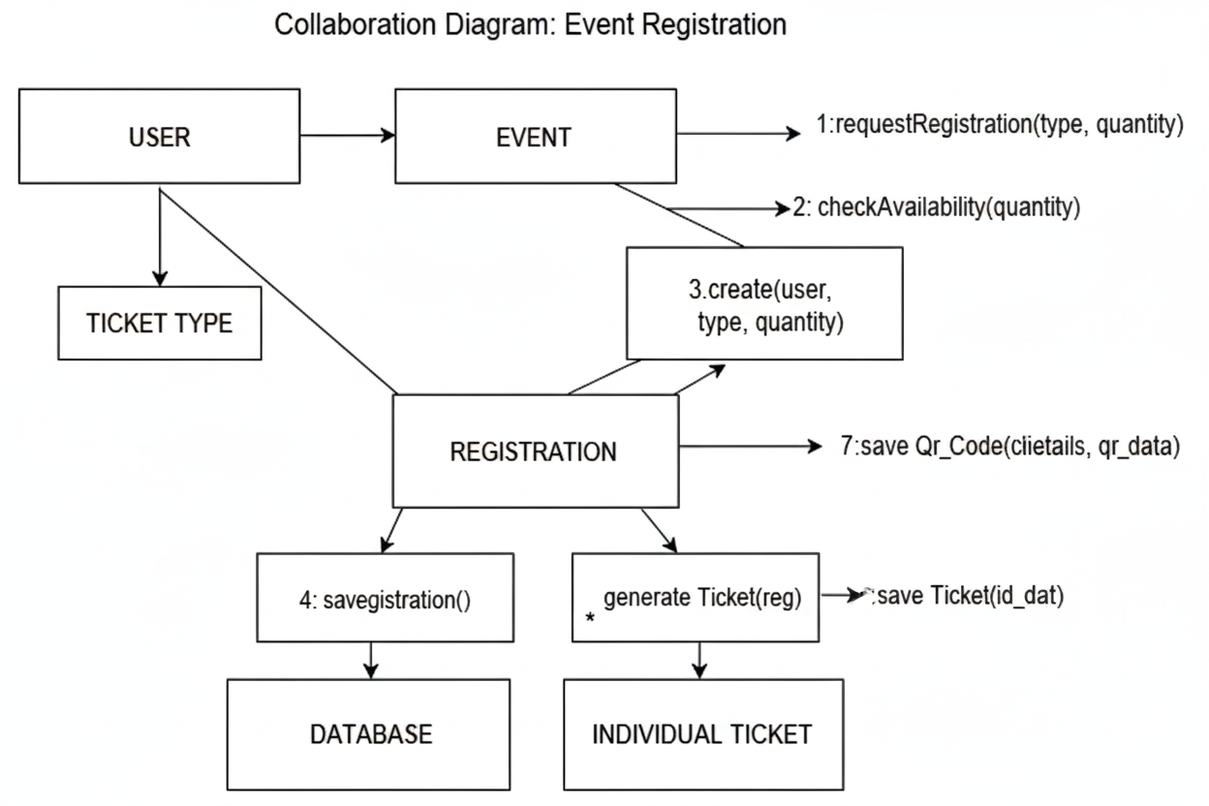

**Deployment Diagram**

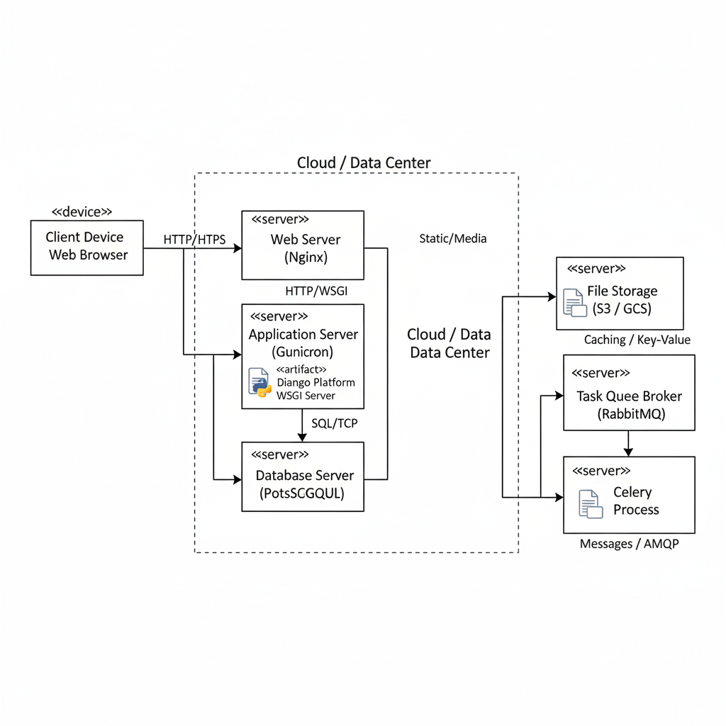

**Black Box Testing:**

|  |  |  |
| --- | --- | --- |
| **Test Case ID** | Test Objective | Expected Result |
| **BB-UM-01** | Verify successful user registration. | User account is created, **JWT token is issued**, and user is redirected to the dashboard. |
| **BB-EM-02** | Verify Organizer can create an event. | Event is successfully created, stored in the database, and **visible on the Organizer's dashboard**. |
| **BB-EM-03** | Verify advanced search filter functionality.t | The search results page loads, and **only current or future events matching the keyword are displayed**. |
| **BB-TR-04** | Verify QR Code generation on registration. | **Two unique QR codes** are generated and displayed on the attendee's digital ticket/dashboard. |

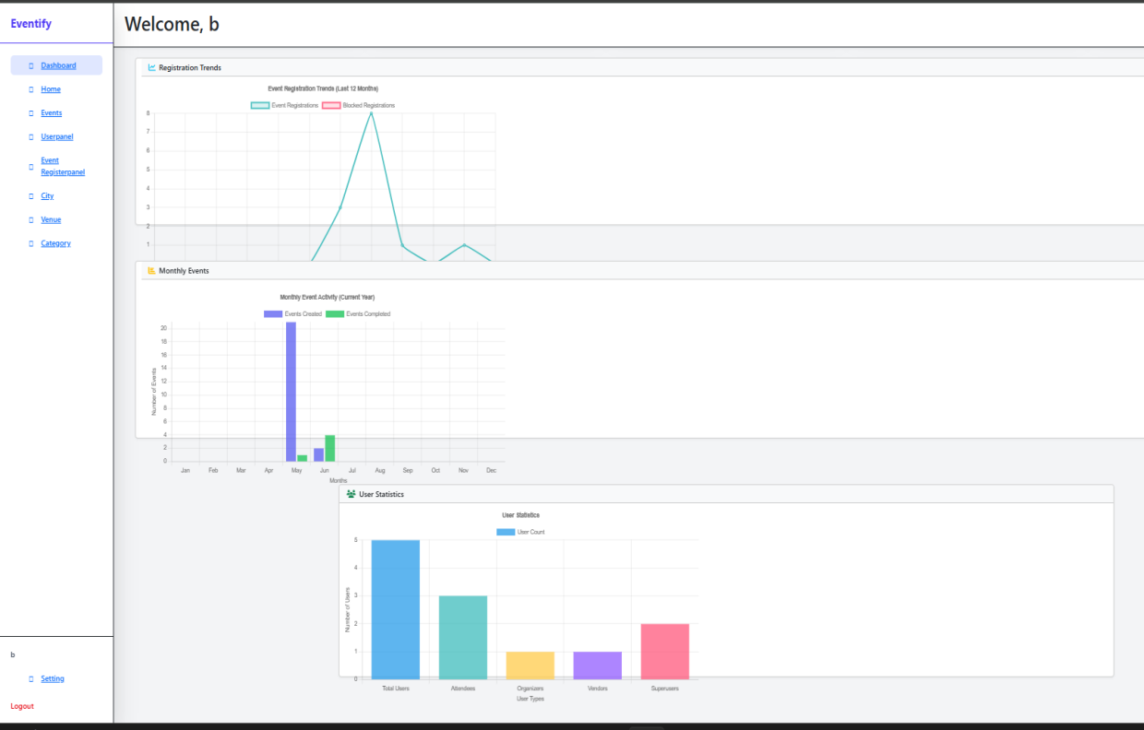  
  
  
  
  
  
  
  
  
  
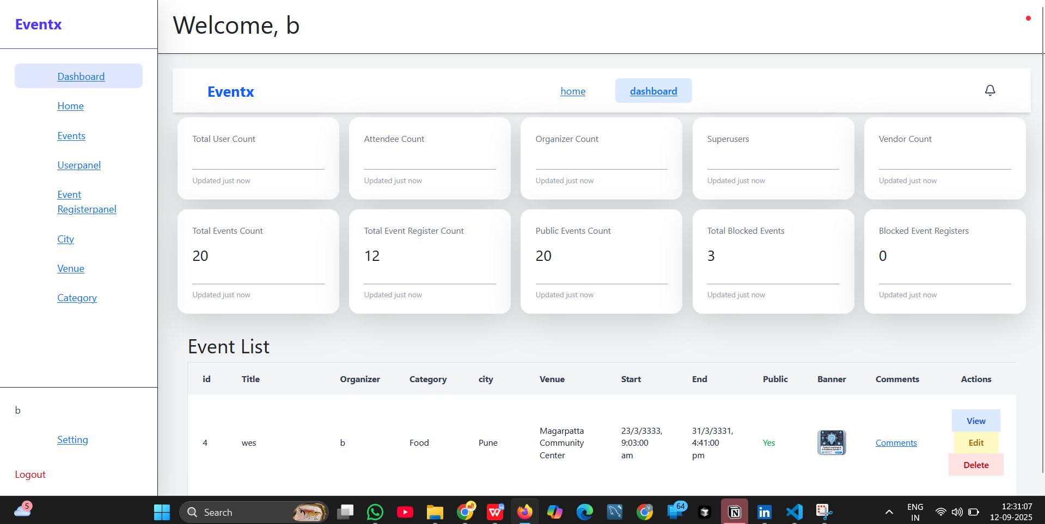

**Whiite Box Testing:**

|  |  |  |
| --- | --- | --- |
| **Test Case ID** | Test Objective | Expected Result |
| **WB-EM-01** | Validate **Role-Based Access Control** (RBAC) on creation. | Attempt to make a POST request to the /api/events/create/ endpoint while authenticated as an **Attendee**. |
| **WB-EM-02** | Verify average\_rating property calculation. | Event is successfully created, stored in the database, and Programmatically confirm that the Event.average\_rating method/property correctly aggregates all related Rating objects and **returns a rounded float**.**visible on the Organizer's dashboard**. |
| **WB-EM-03** | Validate QR data uniqueness and UUID structure. | Execute the EventRegistration.generate\_ticket\_qrs() method twice for the same registration record (quantity > 1) and inspect the output. |

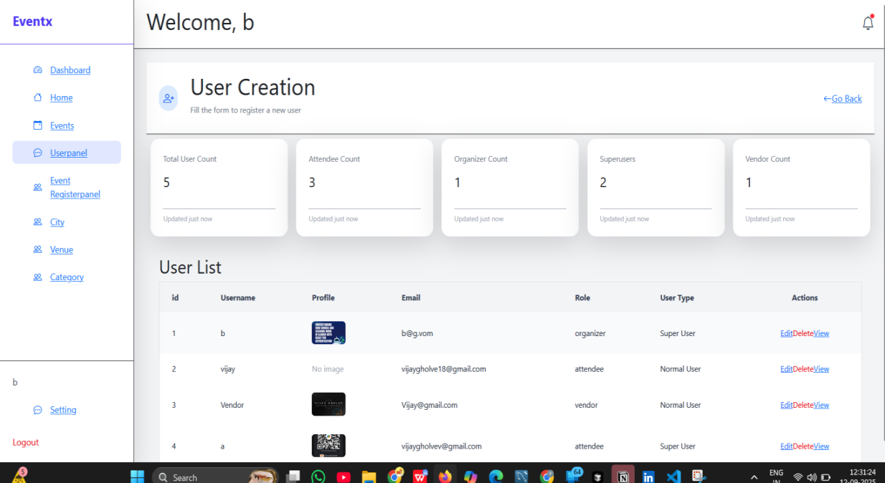  
  
  
  
  
  
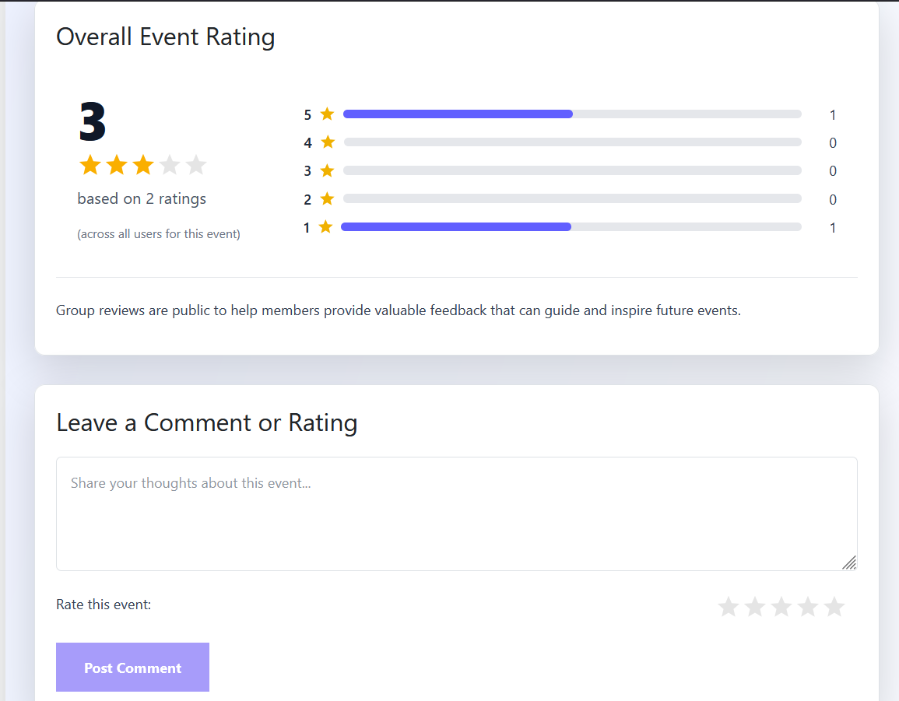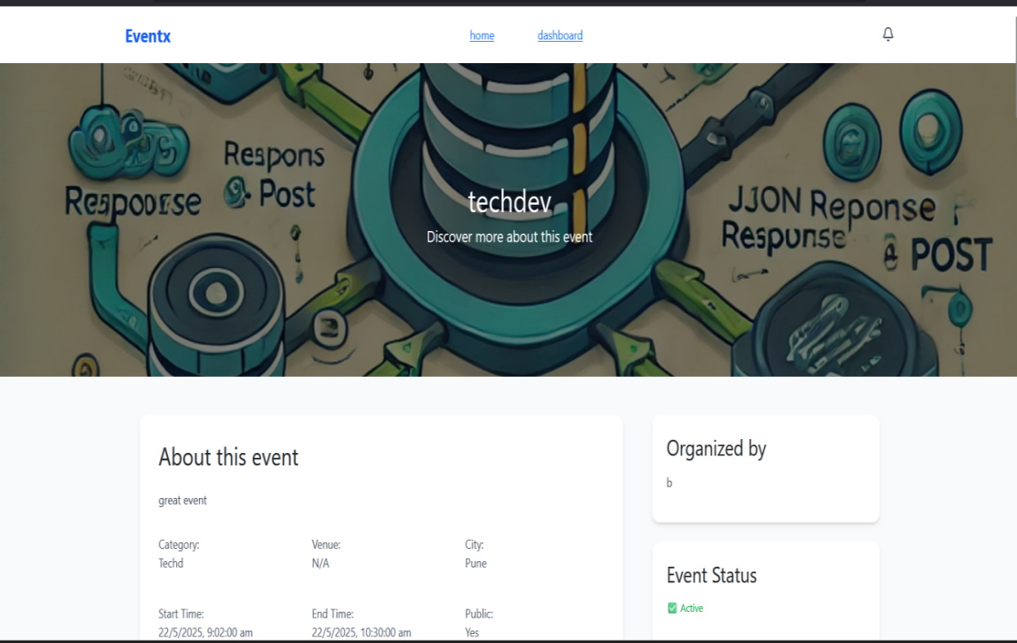  
  
  
  
  
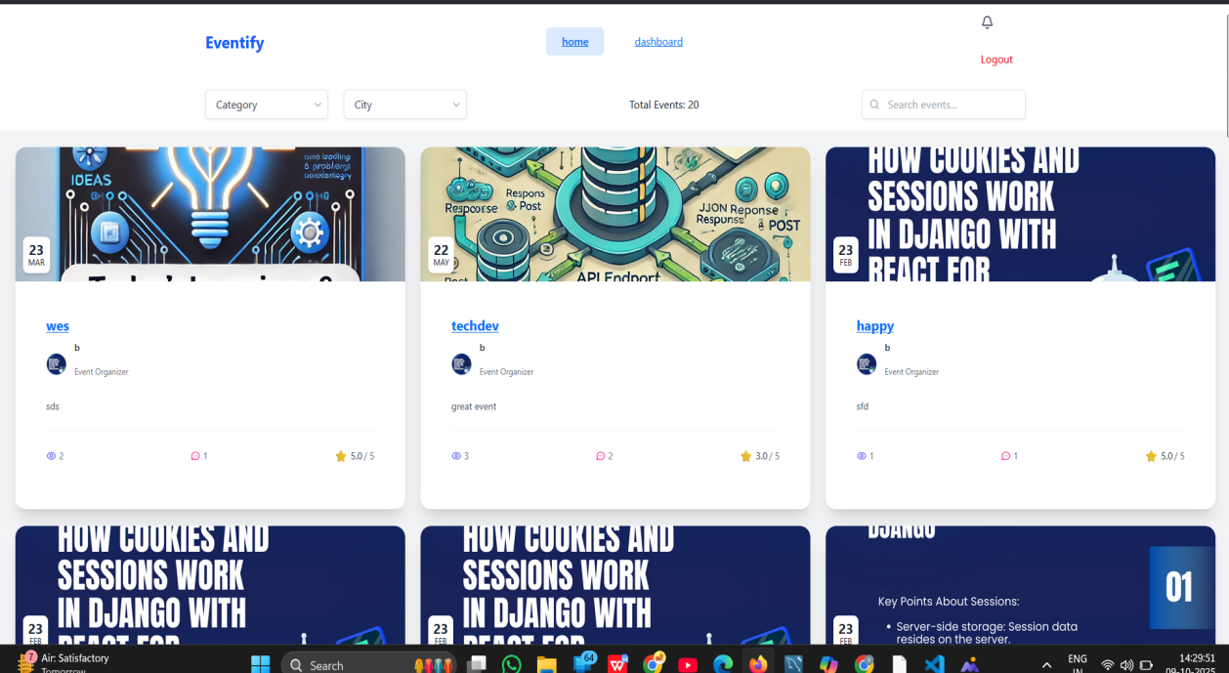

**Project Scope**

* Project Scope: ConnectLocal is scoped as a full-stack web application.
* User Management: Comprehensive user registration, profile creation, and
* authentication.
* Group Management: Functionality for creating, joining, leaving, and
* managing groups, including member roles and moderation tools.
* Event Management: Tools for scheduling, promoting, and managing events
* within groups, including RSVP tracking and attendance marking.
* Communication: Integrated messaging features for group members and
* event attendees, alongside discussion boards.
* Discovery: Advanced search, filtering, and basic recommendation capabilities
* for groups and events.
* Basic Analytics: Dashboards for group organizers to view key metrics on
* group activity and event attendance.
* Responsive Design: Optimized for seamless usage across desktop, tablet, and mobile devices

**CHAPTER 5:**

**IMPLEMENTION**

**DETAILS**

**Software/Hardware Specifications**

**Backend:**

* Language/Framework: Python 3.x with Django (latest stable version).
* API Framework: Django REST Framework.
* Database: PostgreSQL (for scalability and robust features).
* Authentication: Django's built-in authentication system with JWT for
* API token management.
* Image/File Handling: Pillow library for image processing.
* Real-time Communication: Django Channels (for WebSockets) or a
* dedicated messaging queue (e.g., Redis Pub/Sub).
* Deployment Environment: Cloud platform (e.g., AWS EC2/ECS, Google
* Cloud Run, Azure App Service) with containerization (Docker)

**Frontend:**

* Language/Library: JavaScript with React (latest stable version).
* Build Tool: Vite.
* Routing: React Router DOM.
* State Management: Redux Toolkit.
* HTTP Client: Axios.
* UI Framework/Libraries: Tailwind CSS for utility-first styling,
* potentially Material-UI or Ant Design for robust components, Framer
* Motion for animations, Lucide React for icons

### **Conclusion**

The development of **ConnectLocal: Community Meetup Platform** represents a strategic and comprehensive effort to address a significant gap in the digital landscape of social interaction. By providing a unified ecosystem for event discovery, streamlined organization, and genuine community engagement, this project is poised to deliver substantial value to its diverse stakeholders. The platform's scalable architecture, built on robust technologies such as Django and React, along with a strong focus on security and a user-centric design, ensures a reliable, high-performing, and intuitive experience. ConnectLocal's successful implementation will not only modernize the process of event management but also empower individuals to forge meaningful, real-world connections, thereby enriching local communities. The platform's design, guided by a thorough literature review and detailed system analysis, positions it as a forward-thinking solution capable of evolving to meet future market demands and technological advancements.

### 

### **Bibliography and References**

**[1]** The Django Software Foundation. (2024). *Django Documentation*. Retrieved from [https://docs.djangoproject.com/](https://docs.djangoproject.com/" \t "_blank) (The official source for the core backend framework, essential for implementation details.)  
**[2]** Postman. (2024). *JWT Authentication Best Practices*. Retrieved from [https://www.postman.com/jwt-authentication/](https://www.google.com/search?q=https://www.postman.com/jwt-authentication/" \t "_blank) (A resource for understanding and implementing secure, token-based authentication protocols.

**[3]** The React Team. (2024). *React Documentation*. Retrieved from [https://react.dev/](https://react.dev/" \t "_blank) (The primary resource for the frontend library, including hooks and component-based architecture.)

**[4]** O'Reilly Media. (2023). *API Design Patterns: Microservices, CQRS, and Beyond*. (A reference for designing scalable and robust APIs using modern principles, which is critical for the Django REST Framework implementation.)

**[5]** Laux, A. (2022). *Data Modeling for Modern Applications: A Practical Guide*. Packt Publishing. (Informs the creation of the ERD and normalization of the database schema.)

**[6]** Shneiderman, B., Plaisant, C., & Cohen, M. (2020). *Designing the User Interface: Strategies for Effective Human-Computer Interaction*. Pearson. (Offers established best practices for designing intuitive and accessible user interfaces.)